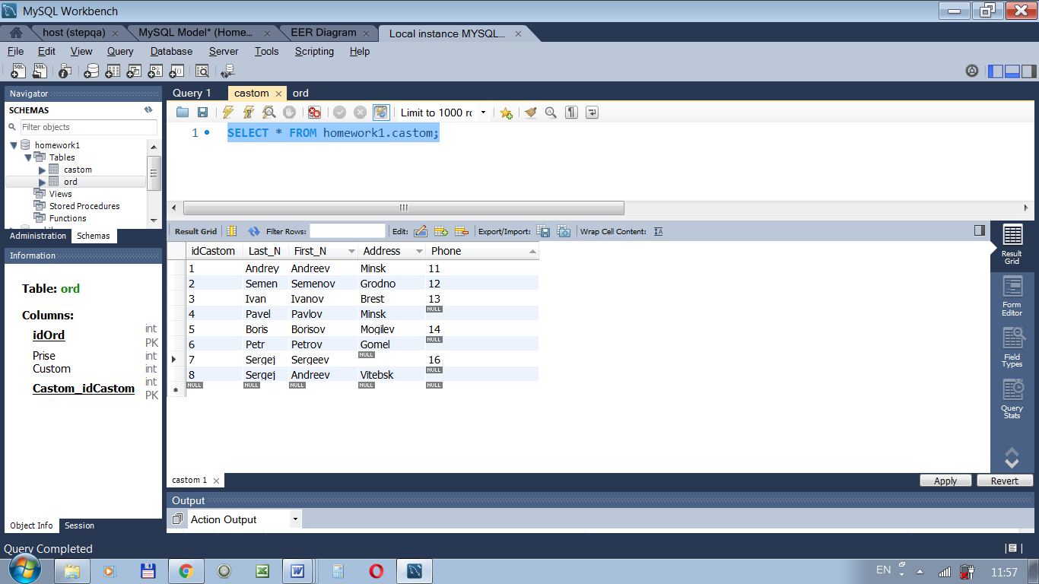

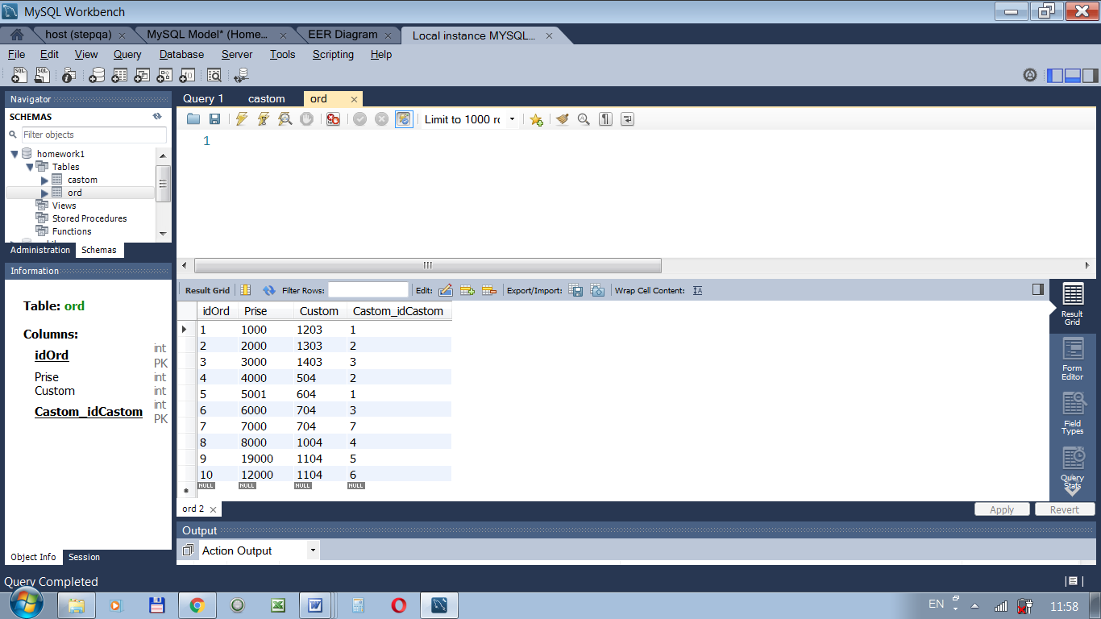

2.1. SELECT ord.prise FROM homework1.ord WHERE ord.prise>5000 AND ord.castom_idcastom is null ORDER BY ord.prise DESC;
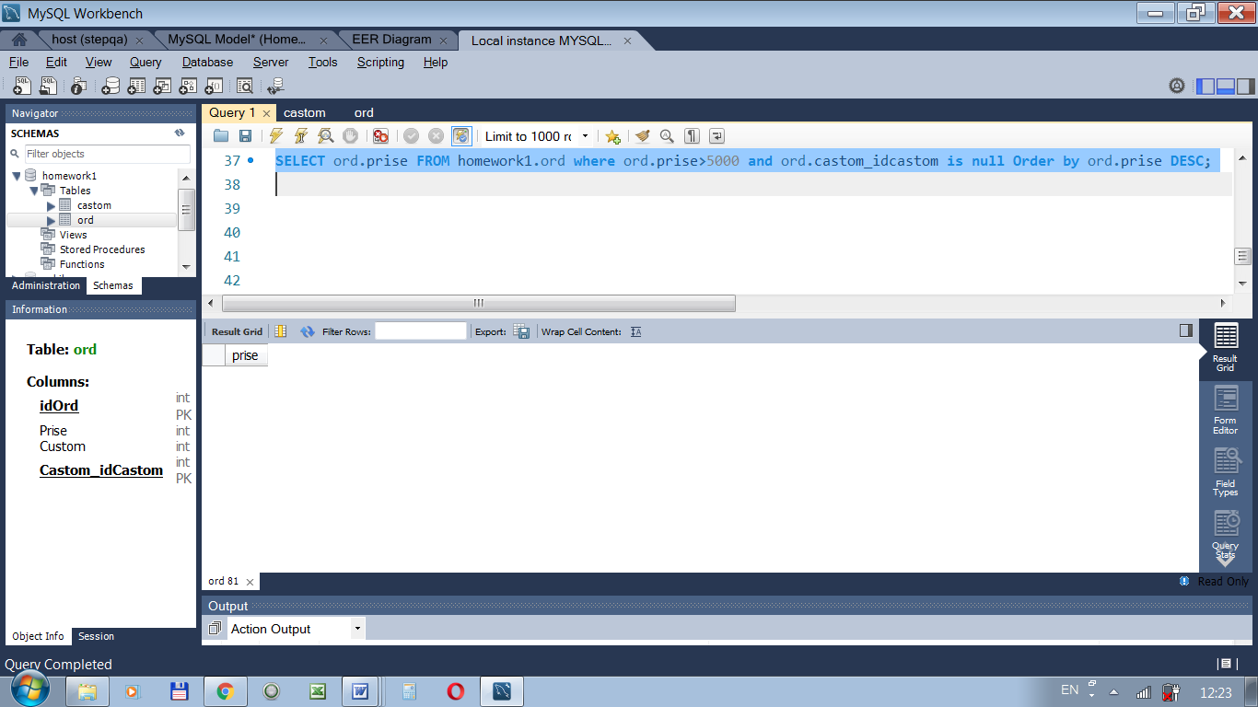

2,2 1 вариант
SELECT ord.prise FROM homework1.ord WHERE ord.prise>5000 and ord.castom_idcastom is not null ORDER BY ord.prise ASC;
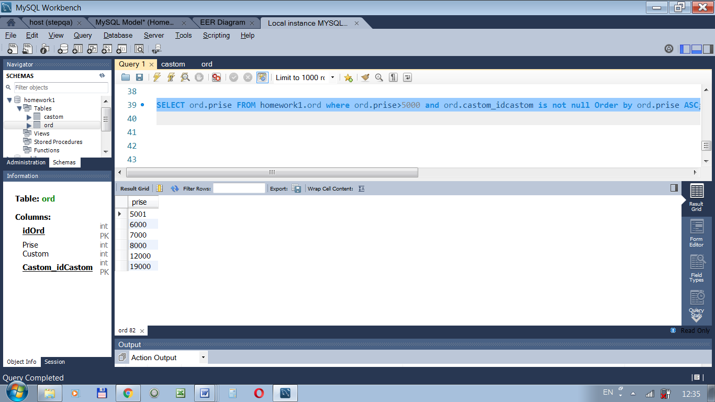

2 вариант
SELECT ord.prise FROM homework1.ord LEFT JOIN homework1.castom ON ord.Castom_idCastom=castom.idcastom WHERE ord.prise>5000 ORDER BY ord.prise ASC;
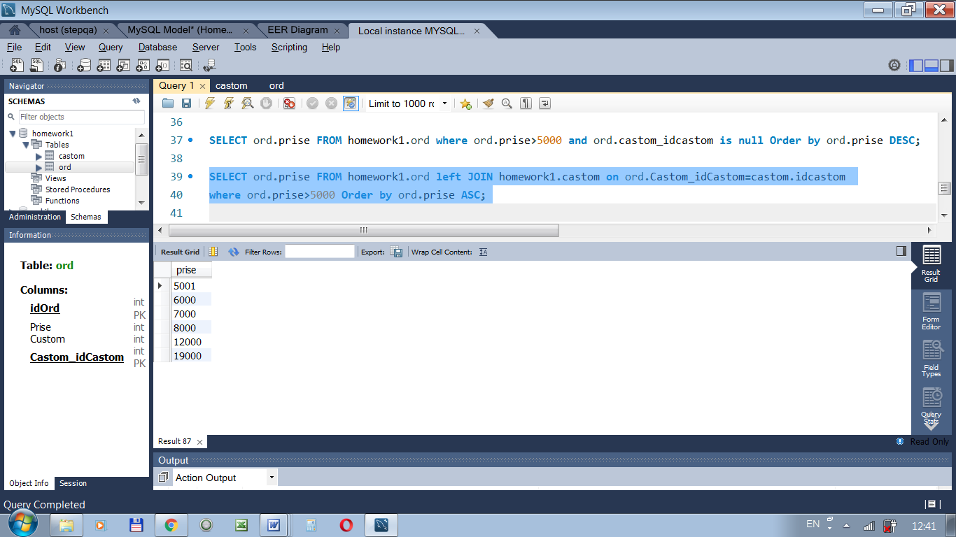
2,3 SELECT castom.idcastom FROM homework1.castom LEFT JOIN homework1.ord on castom.idcastom=ord.Castom_idCastom WHERE ord.idord>5 ORDER BY castom.idcastom ASC;
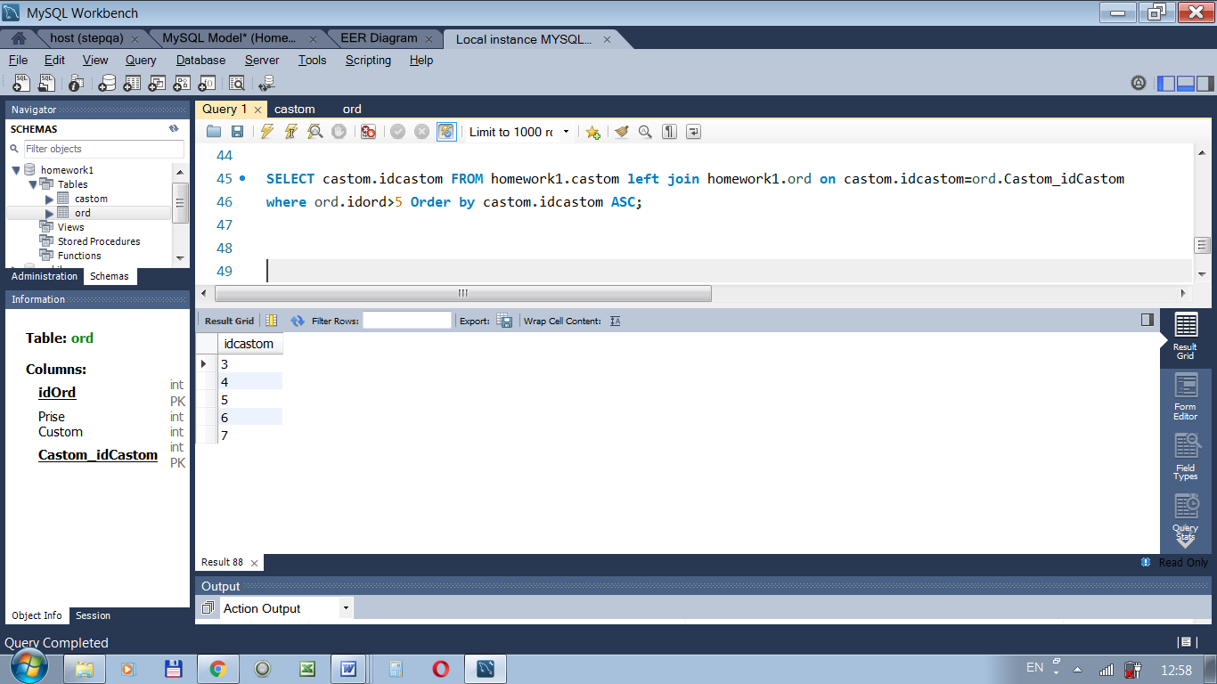

2,4 по городу SELECT A.Last_N, B.Last_N, A.Address FROM homework1.Castom A, homework1.Castom B WHERE A.iDcastom < B.IDcastom AND A.Address = B.Address;
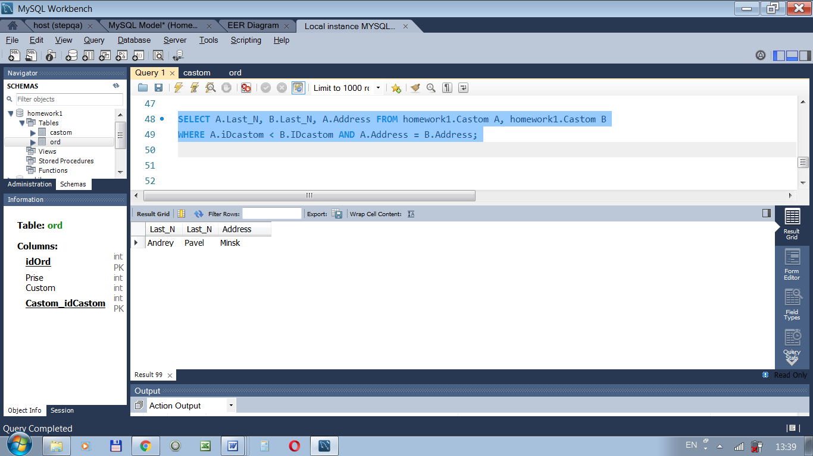
По фамилии SELECT A.First_N, A.idcastom, A.Last_N, A.Address, B.idcastom, B.Last_N, B.Address FROM homework1.Castom A, homework1.Castom B
WHERE A.iDcastom < B.IDcastom AND A.First_N = B.First_N;
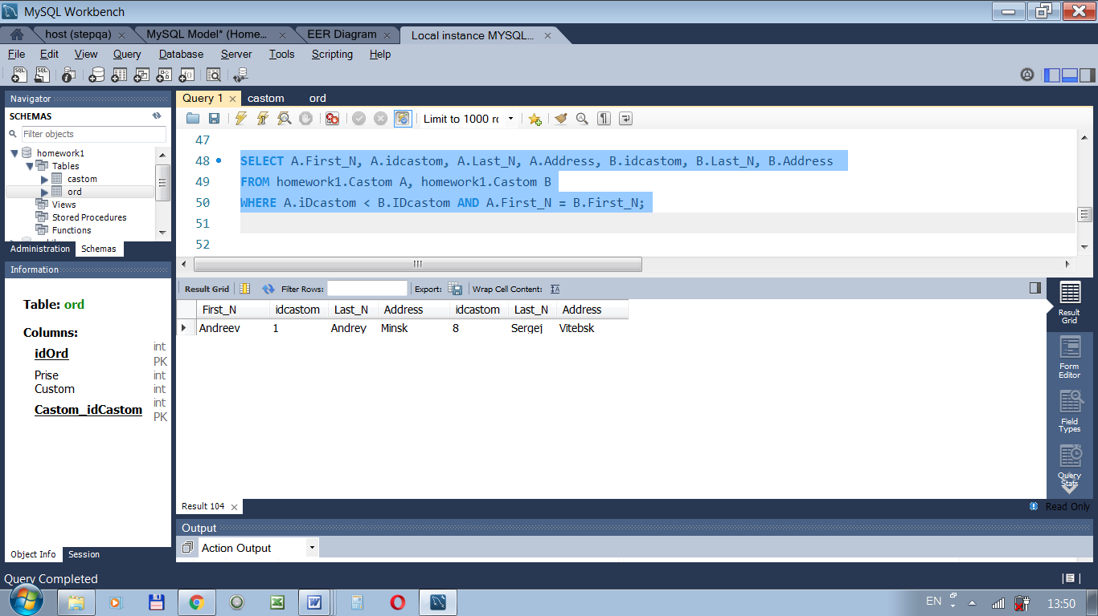

2,1 вариация SELECT * FROM homework1.castom LEFT JOIN homework1.ord
ON castom.idcastom=ord.Castom_idCastom WHERE ord.idord is null;
